Fracking Solution
Course
Institution Affiliation

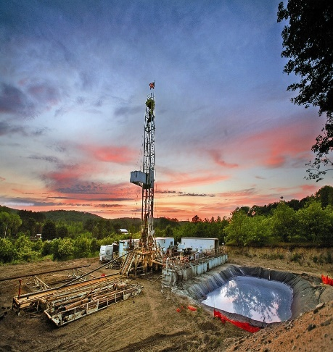
FRACKING SOLUTION DISCOVERED
F
Or many years, fracking has caused many debates due to its numerous effects on the environment and the community at large. However, joy has come to the fracking companies; the fracking solution has been discovered.
Many people have been arguing that fracking is unsafe practice and should, therefore, be burned from being practiced. Others have viewed it to be the major cause of global warming due to its gasses emitted. It is not that oil and gas drilling is bad. It's not just for drilling to result in environmental destruction and pollution. It is all these viewed because sometimes a few of those involved in the drilling process ranging from the management all the way to the worker are greedy or they could be just completely lazy ("Is Cement the Fracking Solution?", 2017).
Picture 1: A Well drilling plant for gas and oil production. ("Fracking - A definition", 2017)
What Is Fracking?
Some may be wondering what fracking is racking. Fracking also referred as hydraulic fracturing is a technique which involves fracturing a rock with pressurized liquid. It involves injecting high-pressure liquid containing sand into a well to create cracks through which petroleum, natural gas and brine flow freely. On withdrawing the hydraulic pressure from the well, fracking fluid remnants hold the fracture open which helps in making it easy for oil and gas extraction (Staff, 2017). This technique started years ago in 1947. And with time it has developed, and many countries have been involved in it ever since. Although this technique has numerous advantages associated with it, it possesses a risk to the environment and the humanity at large. ("Fracking - A definition", 2017) As a result, states have been struggling in making decisions whether this practice should continue or should be burned. With the new-found solution this practice will be safe, and thus the country will be able to benefit from its advantages without fear of risks fully.
?
Risk involved in fracking
For many years there has been constant debate especially in the United States concerning the process of fracking. The discussion has been to argue out whether this process shoal be stopped or left to continue due to its environmental pollution. On the other hand, this process has been able to provide gas security as well as driving down gas prices both in the US and Canada at large (Staff, 2017). Many research has been conducted to prove the impact of this process on the environment which is believed to have also contributed to global warming. The environment risk involved is considered to be as a result of leakages that come from the well during and after the process. On average from research conducted, it was found that from ascertaining well tons of waste are disposed to the environment which is as a result of leakages form fracking process. Current research shows that approximately 6-7% of wells are reported to have failed in the past three years leading to leakages of gas and also water contamination. Over 10,000 wells are projected to be build will also have a structural problem which could result in more water pollution, gas spillage, and worse conditions maybe. This observation led to research to be carried out to find ways of coming up with solution to the fracking solution and make it a safe practice ("Is Cement the Fracking Solution?", 2017).
Research done
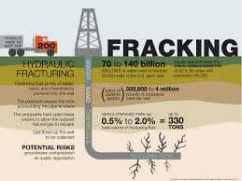
New Care for Environment Conservation Institute (NCECI) based in America did research to find out how cement would help to solve the fracking environment pollution problem. The research was conducted by a group of four among which are two environment conservation and global warming analyst, one chemical waste and sewage analyst and a petroleum and drilling specialist. The research was conducted for 11 years, which involved data collection and insensibly analyzing the data concerning the effect of the produced waste through leakages to the environment, its contribution to global warming, and also its contribution to community health risks. International standards of measurements were used as a reference to come up with the results and to give the recommendation. An analysis was done basing on 98,578 reports which were obtained from 745 conventional and unconventional gas and oil wells within the United States of America. The report considered are those that were ranging from January 2000 to December 2016 concerning the waste produced by the different wells. From the analysis, the wells drilled from 2000 to 2007 when cement was not considered showed that they 12,997 tones on average of waste was produced from the well leakage to the environment causing danger to the environment and contributed 40% to global warming and viable to cause over 25 types of harm to the community around. Wells drilled as from 2007 and 2012 were cement was incorporated in drilling but at improper ratio hence prone to cracking and impairment recorded 7,126 tons of waste from the wells spill contributing to 21% of global warming and causing 14 types of harm to the nearby community. These were contrary to the data collected between 2012 and 2016. This period is marked by the numerous research which was carried by the Cement Manufacturing and Processing Industry under hired scientist to come up with the correct ratio of cement to the sand mixture to be used in well ceiling. The data collected showed an improvement with 1,735 tones being exposed to the environment from leakages of the wells and casing five risks to the community around with contribution of 3% of global warming.
Picture 2: fracking process representation (Froelich & Froelich, 2017)
Cement- the new-found solution to fracking.
However, the research showed that apart from the normal ratio which was developed by the scientist from the Cement Manufacturing and Processing Industry which was made as a regulation to be observed by all wells drilling company of 4:1 cement to sand ratio. Incorporating such ration with ballast in a ratio of 8:2:1 cement, sand, and ballast respectively gives better results from the one attained currently. From the petroleum and well drilling expert, this ration will be able to seal the wells completely without allowing even the most volatile gas to escape. This shows that fracking will be safe process without any harm to the environment of the society. Furthermore, pollution risk associated with fracking will be reduced to 0.91% which shows that no further harm to global warming since this percentage is safe.
Recommendation
The organization recommended that all the wells, not only those around the united states but also those in the other countries should adapt to the use of this new ratio of cement. By this, there would be prevention of risks involved with global warming and environmental pollution Wells situated near communities should not only adapt to the new ratio of sand to cement ratio but introduce the use of cement, sand to ballast ratio of 8:2:1 which has proved to be the most effective for complete sealing of drilled wells. The government should also bring to closure all the wells that are still operational and are not sealed using the required ratio of cement to sand.
8:4:1 cement, sand to ballast= Zero leakages in Wells
With the implementation of all these, fracking will be the save practice and should raise no further concern to environmental pollution.

References
Fracking - A definition. (2017). Gove Online. Retrieved 7 December 2017, from http://www.goveonline.com.au/fracking/
Froelich, A., & Froelich, A. (2017). Google requested to label anti-fracking websites as ‘fake news’. Inhabitat.com. Retrieved 7 December 2017, from https://inhabitat.com/google-requested-to-label-anti-fracking-websites-as-fake-news/\
Is Cement the Fracking Solution?. (2017). Power Shift Network. Retrieved 7 December 2017, from https://powershift.org/blogs/cement-fracking-solution
Staff, I. (2017). Fracking. Investopedia. Retrieved 7 December 2017, from https://www.investopedia.com/terms/f/fracking.asp
Staff, I. (2017). Fracking. Investopedia. Retrieved 7 December 2017, from https://www.investopedia.com/terms/f/fracking.asp

